1. Investigate *Moving Man* by having the man move using the sliders. Use the playback features to look at the graphs. While you make observations think about the reasons the graphs look the way they do.

2. Make a chart like the one below on your own paper. Without using *Moving Man*, sketch what you think the graphs would look like for the following scenario and explain your reasoning.

|  |  |
| --- | --- |
| Scenario: The man starts at the tree and moves toward the house with constant velocity | |
| Position - time graph | Explain your reasoning for the graph’s appearance |
| Velocity - time graph | Explain your reasoning for the graph’s appearance |
| Acceleration - time graph | Explain your reasoning for the graph’s appearance |

3. Now, use the *Moving man* simulation to verify or correct your predicted graphs and reasoning with a different color pen.

4. Make new charts for each of the following scenarios. Predict what you think the graphs will look like, and then use *Moving man* to verify or correct your predicted graphs and reasoning with a different color pen.

a. The man starts three meters from the house and accelerates towards the tree.

b. The man stands still while he talks on his cell phone at the middle of the sidewalk, then walks toward the house at a constant rate trying to get better cell reception. He comes to a sudden stop when the coverage is good (about a meter before the house) and stands still to finish his conversation.

c.. The man starts close to the house, stands still for a little while, then walks toward the tree at a constant rate for a while, then the slows to a stop.

5. Sketch the position, velocity and acceleration graphs for the following scenario:

A man wakes up from his nap under the tree and speeds up toward the house. He stops because he is worried that he dropped his keys. He stands still as he searches his pockets for his keys. Once he finds them, he continues calmly to walk toward the house and then slows to a stop as he nears the door.

6. Write a possible scenario for the following graph. Then attempt to have the moving man recreate the graph. 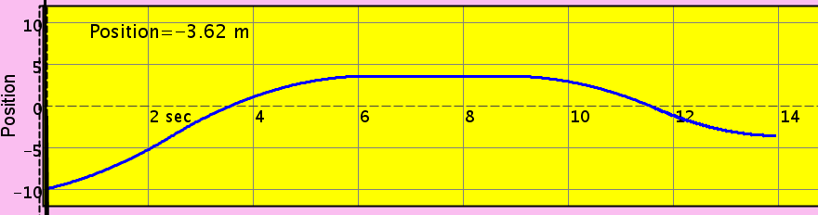 time